LIMITED POWER OF ATTORNEY

BE IT ACKNOWLEDGED that I, Richard Farnsworth (principal name), with a social security number of XXX-XX-XXX (SSN), the “Principal”, do hereby grant a limited and specific power of attorney to Vinay Morrison (agent name) of 1234 Street Lane, El Dorado, Arkansas 71731 (address) with a phone number of +1(870)321-1234 (phone) as my “Attorney-in-Fact”.

Said Attorney-in-Fact shall have full power and authority to undertake and perform only the following acts on my behalf:

1.Closing the sale of the residential property @ 412 Duplex Street, El Dorado AR 71731

2. Deposit the funds from the sale to my savings account, #12345678

3.

4.

5.

The authority herein shall include such incidental acts as are reasonably required to carry out and perform the specific authorities granted herein. My Attorney-in-Fact agrees to accept this appointment subject to its terms, and agrees to act and perform in said fiduciary capacity consistent with my best interest, as my Attorney-in-Fact in its discretion deems advisable. This power of attorney is effective upon execution.

This power of attorney may be revoked by any of the following:

(Initial and Check All Applicable Box/es)

RF ☒ - By the Principal at any time by signing a Revocation.

RF ☒ - When the act(s) designated above have been completed.

______ ☐ - On the ____ day of _______________________, 20___.

This power of attorney form shall automatically be revoked upon my death or incapacitation, provided any person relying on this power of attorney shall have full rights to accept and reply upon the authority of my Attorney-in-Fact until in receipt of actual notice of revocation.

State Law. This Power of Attorney is governed by the laws of the State of Arkansas .

Signed this 15th day of August , 2030 .
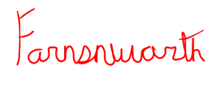
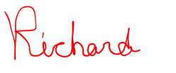

Principal’s Signature

Richard Farnsworth

Principal’s Print Name

ACCEPTANCE OF APPOINTMENT

I, Vinay Morrison the attorney-in-fact named above, hereby accept appointment as attorney-in-fact in accordance with the foregoing instrument.
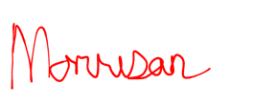
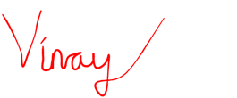

________________________________
Attorney-in-Fact’s Signature

Vinay Morrison
Attorney-in-Fact’s Printed Name

WITNESSES

We, the witnesses, each do hereby declare in the presence of the principal that the principal signed and executed this instrument as his Power of Attorney in the presence of each of us, that he signed it willingly, that each of us hereby signs this Power of Attorney as witness at the request of the principal and in his presence, and that, to the best of our knowledge, the principal is eighteen years of age or over, of sound mind, and under no constraint or undue influence.

________________________________ _________________________________________
Witness Signature Address
Not required in AR per § 28-68-105
________________________________ _________________________________________
Witness Print Name City, State & Zip Code

________________________________ _________________________________________
Witness Signature Address

________________________________ _________________________________________
Witness Print Name City, State & Zip Code

ACKNOWLEDGMENT OF NOTARY PUBLIC

STATE OF ___________________

COUNTY ____________________

To be completed by a Notary Public ONLY
On this ____ day of _______________________, 20___, before me appeared _______________________________, as Principal of this Power of Attorney who proved to me through government issued photo identification to be the above-named person, in my presence executed foregoing instrument and acknowledged that he executed the same as his free act and deed.
_________________________________________
Notary Public
My commission expires: _____________________

