[SAMPLE] MEDICAL POWER OF ATTORNEY
IMPORTANT INFORMATION

IT IS IMPORTANT THAT YOU REVIEW THE FOLLOWING INFORMATION BEFORE YOU SIGN THIS DOCUMENT. READ THE INFORMATION CAREFULLY AND SEEK GUIDANCE FROM A HEALTHCARE PROFESSIONAL OR ATTORNEY IF YOU DO NOT UNDERSTAND ANY OF THE TERMS.

By signing this document, you are giving authority to the person you are designating as your agent to make medical decisions on your behalf. Medical decisions can include any medical service, treatment, medical procedure, diagnosis or treat both mental and physical conditions. Your agent will be able to act with the same authority you would have if you were able to act for yourself and will have the authority to consent, refuse to consent to medical treatment including decisions about withdrawing or withholding life-sustaining treatment. It is, therefore, important that you know and trust your agent and that your agent is aware of your preferences for health care treatment.

Even after you sign this document, you will still be able to make your health care decisions assuming you are still considered mentally competent. Your agent cannot act on your behalf until your physician has determined that you are no longer physically or mentally able to make medical decisions.

The person you choose as your agent must be at least eighteen years old and someone that you trust with your health care. Your agent is not liable for any decisions they make on your behalf, as long as those decisions were made in good faith. You should make sure that you have chosen agent wants to take on the role as agent. Discuss your medical preferences with your agent so they are aware of your wishes. Review this document with your agent so they are aware of their role. You also may choose a back-up agent in case your other agent is unavailable to act. Your back-up agent should also be over 18 and aware of your preferences.

You may revoke this document at any time while you are still competent to do so. You may revoke it by telling your medical provider and your agent that you are revoking the document or you may provide them a written revocation. If you execute another power of attorney later, that will have the effect of revoking this one.

In order for this document to be valid, it must be signed in the presence of a notary or two witnesses. If you choose to have two witnesses sign, they must be at least 18, competent and independent and not your agent or related to your agent.

MEDICAL POWER OF ATTORNEY

APPOINTMENT OF HEALTH CARE AGENT

I, Connor Moss (Principal Name) of 3022 Evergreen Lane (Street), City of Los Angeles , State of California (HEREINAFTER known as the “Principal”) hereby appoint, Tommie Riddle (Agent Name) of 3570 Powder House Road (Street), City of
Los Angeles , State of California (HEREINAFTER known as the “Agent”)as my Agent to make any and all medical decisions on my behalf, except to the extent I limit those decisions in this document. This power of attorney takes effect if my doctor certifies in writing that I can no longer make my own health care decisions. My agent can be reached at the following contact information:
Home Phone: (213) 123-4567 Work Phone: (213) 111-1111
Cell Phone: (213) 765-4321 E-Mail: tommie@email.com

AGENT LIMITATIONS

My agent is authorized to make all medical decisions on my behalf EXCEPT for the following:
Whether or not I (Connor), should be taken off of life support (regardless of my physical or mental condition). I would like the decision to be made as a family, with everyone in agreement prior to taking action. .

APPOINTMENT OF ALTERNATE AGENT

If my agent appointed above is unable or unwilling to serve as my agent, I appoint the following person(s) to serve as agents in the order set forth below with the authority to make health care decisions on my behalf as provided herein:

- First (1st) Alternate Agent
Name: Cynthia Morales Phone: (707) 222-2222
Address: 4883 Fairway Drive, Ukiah, California 95482

- Second (2nd) Alternate Agent
Name: Shaunna Valentine Phone: (707) 333-3333
Address: 1258 Marietta Street, Fremont, California 94539

ORIGINAL AND COPIES OF THIS DOCUMENT

The original document is/will be filed in the following place: My Attorney (Jim Hope, 123 Marve Road, Los Angeles, California 90005 .

I have/will provided copies of my medical power of attorney to the following: Brother (Jim Moss) and my Cousin (Kevin Moss) .

DURATION

Unless stated otherwise herein, this document shall remain in effect until I revoke it. I understand that I cannot revoke this document during the time I am considered incompetent to make my own decisions.

(Optional - Initial and Check if applicable)

______ ☐ This power of attorney shall expire on ____ day of __________________, 20____.

PRIOR MEDICAL POWER OF ATTORNEY

By signing this document, I hereby revoke any and all prior medical powers of attorney that I may have executed.
EXECUTION

YOU MUST DATE AND SIGN THIS POWER OF ATTORNEY. YOU MAY SIGN IT AND HAVE YOUR SIGNATURE ACKNOWLEDGED BEFORE A NOTARY PUBLIC

OR

YOU MAY SIGN IT IN THE PRESENCE OF TWO COMPETENT ADULT WITNESSES NOT RELATED BY BLOOD OR MARRIAGE.

SIGNATURES

I / We hereby execute this document on 24th day of August 2025 , in the City of Los Angeles State of California .
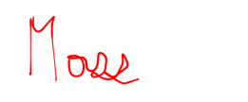
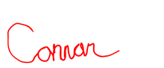

Principal’s Signature:
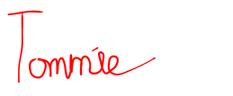
Print Name: Connor Moss
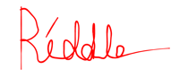
Agent’s Signature:
Print Name: Tommie Riddle
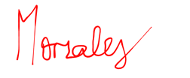
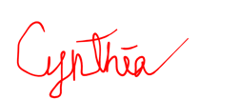
1st Alt. Agent’s Signature:
Print Name: Cynthia Morales
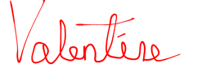
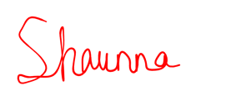
2nd Alt. Agent’s Signature:
Print Name: Shaunna Valentine
NOTARY ACKNOWLEDGMENT

STATE OF __________________
COUNTY __________________ ss.
On this ____ day of __________________, 20____, before me appeared

____________________, as Maker of this Medical Power of Attorney who proved to me through government issued photo identification to be the above-named person, in my presence executed foregoing instrument and acknowledged that he/she executed the same as his/her free act and deed.
To be completed by a Notary Public ONLY

_________________________________________
Notary Public
Print Name: _____________________
My commission expires: _____________________

- - - - - - - - - - - - - - - - - - - - - - OR - - - - - - - - - - - - - - - - - - - - - -

WITNESS STATEMENT AND ACKNOWLEDGMENT

I am not the person appointed as agent or successor agent in this medical power of attorney. I am not related to the maker of this document by blood or marriage. I am not entitled to any portion of the maker's estate, nor do I have any claim against the maker’s estate. I am not the attending physician of the maker or an employee of the attending physician. I am not involved in providing direct patient care to the maker and am not an officer, director, partner, or business office employee of the health care facility or of any parent organization of the health care facility.

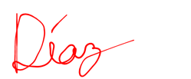
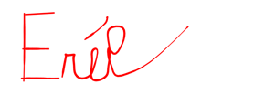
SIGNATURE OF FIRST WITNESS
Signature: ___________________________________________ Date: 08/24/2025
Print Name: Erik Diaz
Address: 5020 Polk Street, San Francisco, California 94107

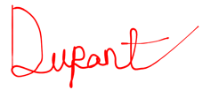
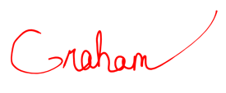
SIGNATURE OF SECOND WITNESS
Signature: ___________________________________________ Date: 08/24/2025
Print Name: Graham Dupont
Address: 1104 Larry Street, San Francisco, California 94107

