[SAMPLE] REVOCATION OF POWER OF ATTORNEY FORM

STATE OF CALIFORNIA §

COUNTY OF SANTA CLARA §

I, Frank Howard (Principal), with a mailing address of
123 Oliver Street , City of Palo Alto , State California
hereby revoke all Powers of Attorney executed prior to the 14th day of
September , 2030 , made by me and appointing Bridget Butler
as my Attorney-in-Fact, and Timmy Neil as my successor Attorney(s)-in-Fact.

IN WITNESS WHEREOF, I have hereunto set my hand on this the 14th day of
September , 2030
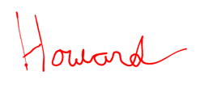
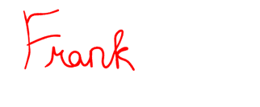

______________________________
Signature of Principal

WITNESS ACKNOWLEDGEMENT

The foregoing Revocation was signed by Frank Howard in our presence, and we, at their request and in their presence, and in the presence of each other, each of us being over the age of 18 years, have hereunto subscribed our names as Witnesses on this 14th day of September , 2030

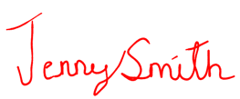
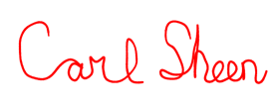

_______________________________ _______________________________
Signature of Witness Signature of Witness

123 Witness Street 321 Witness Road
Street Address Street Address

Palo Alto, CA 94020 Modesto, CA 95350 .
City, State and Zip Code City, State and Zip Code

NOTARY ACKNOWLEDGEMENT

STATE OF §

COUNTY OF §

To be completed by a Notary Public ONLY
BEFORE ME, the undersigned authority, on this day personally appeared __________________________, who, having been duly sworn, states that he/she is executing this Revocation in the presence of the Witness(es) as shown above and for the purposes therein expressed.

SWORN TO, SUBSCRIBED AND ACKNOWLEDGED BEFORE ME by
__________________________ and by the said Witness(es) __________________________, and __________________________, on this ____ day of ____________________, 20___.

__________________________
Notary Public
(seal)
__________________________
Print Name

My Commission Expires: ________________

