ALL TERRAIN VEHICLE (ATV) BILL OF SALE

Date of sale: 06/03/2030_____

For goods and other consideration and in payment of the sum of $5400
the undersigned Seller: Leona Huffman (Seller’s Name)
Of: 849 Timber Crest Road, Teller, AK 99778 (Seller’s Address)
Hereby sells and transfers to Buyer: Benn Cortes
Of: 4704 Ventry Drive, Brevig Mission, AK 99778 (Buyer’s Address)

The following All-Terrain Vehicle (ATV), hereinafter “ATV”:

Make: Yamaha Model: YFZ450 Year: 2015 ____________
Color: Blue CCs: 450 Title Number (if applicable): 452AB23S4__________
Odometer Reading: 1800 ☐ Kilometers ☒ Miles
17-Digit Vehicle Identification Number (VIN): 1HGBH42JXMN109186___________________

Sale is subject to the following representations and conditions: Buyer must pay full sum in CASH .
The Buyer agrees to pay $5400 (US Dollars) to the seller, via the following (check one):

☒ Cash | ☐ Cashier’s / Certified Check | ☐ Credit / Debit Card | ☐ Other: _________________

IN WITNESS THEREOF, on this 9th day of June , 2030 , the Buyer accepts receipt of this Bill of Sale and understands that the above ATV is sold in “as is” condition with no guarantees or warranties (other than any remaining factory warranty), either expressed or implied, for ATV.

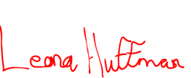

Leona Huffman 06/09/2030
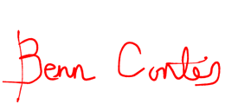
Seller’s Printed Name Seller’s Signature Date

Benn Cortes 06/09/2030
Buyer’s Printed Name Buyer’s Signature Date

