SAMPLE MOTORCYCLE BILL OF SALE

Date of sale: 06 / 25 / 2025

For goods and other consideration and in payment of the sum of $18,000
the undersigned Seller: Scott Simons (Seller’s Name)
Of: 123 Cross Drive, Elizabethtown, Kentucky 42701 (Seller’s Address)
Hereby sells and transfers to Buyer: Shae Alfred
Of: 321 Hurry Street, Winchester, Virginia 22602 (Buyer’s Address)
the following described motorcycle:
Make: BMW Model: F 850 GS Year: 2019 CC: 853____
Color: Blue/red Odometer: 1200 VIN: 11A33B44CGJ5422QL __________
The above described motorcycle is to be sold free and clear of any liens, encumbrances, or mortgages. Seller certifies that they are the legal and true owner of the motorcycle and is to be sold in “as-is” condition.

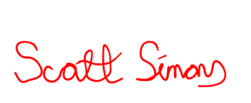
IN WITNESS WHEREOF, the buyer and seller agree to the terms of this Bill of Sale on the 6th day of June 2025 .
Scott Simons 06/25/2025
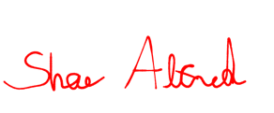
Seller’s Printed Name Seller Signature Date

Shae Alfred 06/25/2025
Buyer’s Printed Name Buyer Signature Date

- - - - - - - - - - - - - - - - - - - - - - - - - - - - - - - - - - - - - - - - - - - - - - - - - - - - - - - - - - - - - - - - - - - - - -

Witness Signatures are Optional
Witness Printed Name Witness Signature Date

Witness Printed Name Witness Signature Date

ACKNOWLEDGMENT OF NOTARY PUBLIC

STATE OF ______________________
____________________ COUNTY, ss.

On this ____ day of _____________________, 20___, before me appeared ______________________, as Seller of this Bill of Sale who proved to me through government issued photo identification to be the above-named person, in my presence executed foregoing instrument and acknowledged that he/she executed the same as his/her free act and deed.
To be completed by a Notary Public ONLY

___________________________________
Notary Public
My commission expires: _______________

STATE OF ______________________
____________________ COUNTY, ss.

On this ____ day of _______________________, 20___, before me appeared ______________________, as Buyer of this Bill of Sale who proved to me through government issued photo identification to be the above-named person, in my presence executed foregoing instrument and acknowledged that he/she executed the same as his/her free act and deed.
To be completed by a Notary Public ONLY

___________________________________
Notary Public
My commission expires: _______________

