SAMPLE BUSINESS BILL OF SALE
- PARTIES. This document was signed on the 3rd day of November 2030 , between Ayden Burnett with a street address of 1162 Cavern Road
City of Edinburgh , State of Indiana (46124) (Hereinafter known as the “Buyer”) and Rose Abbott with a street address of 2693 Perry Street
City of Port Sanilac , State of Michigan (48469) (Hereinafter known as the “Seller”).

- BUSINESS. Seller acknowledges they have the right to sell the business entity known as
BILLS HOTDOGS, LLC incorporated in the State of Indiana with a principal office located at 123 Hot Dog Road City of Port Sanilac , State of Michigan along with all its assets, shares, ownership interest, personal property, employees, leases, contracts, trademarks, copyrights, and any other tangible or intangible interest (Hereinafter known as the “Business”).

- PURCHASE PRICE. The Buyer and Seller agree to a purchase price of $325,000 (US Dollars) to be acceptable for the sale of the Business. The Buyer agrees to make the funds available on the day of the transfer of the Business known as the 10th day of
November 2030 . Before, during, and after the sale, the Seller agrees to do everything in their power to educate the Buyer about the practice of the Business.
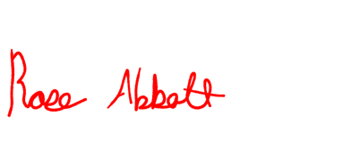
- SIGNATURES.
Rose Abbott
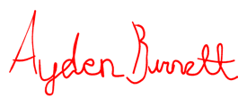
Seller Printed Name Seller Signature

Ayden Burnett
Buyer Printed Name Buyer Signature

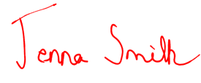
- - - - - - - - - - - - - - - - - - - - - - - - - - - - - - - - - - - - - - - - - - - - - - - - - - - - - - - - - - - - - - - - - - -

Jenna Smith
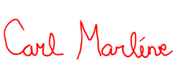
Witness Printed Name Witness Signature

Carl Marline
Witness Printed Name Witness Signature
ACKNOWLEDGMENT OF NOTARY PUBLIC

State of
County of

On the day of 20 before me, , personally appeared, , , proved to me on the basis of satisfactory evidence to be the person(s) whose name(s) is/are subscribed to the within instrument and acknowledged to me that he/she/they executed the same in his/her/their authorized capacity(ies), and that by his/her/their signature(s) on the instrument the person(s) or the entity upon behalf of which the person(s) acted, executed the instrument.
To be completed by a Notary Public ONLY
WITNESS my hand and official seal,

___________________________________ Notary Public
(Seal)
My commission expires: _______________

