CAT / KITTEN BILL OF SALE

- CAT / KITTEN INFORMATION

Cat / Kitten name (if any): Snuggles
Registration #: AB34 L99
Breed: Maine Coon
Color: Brown
Sex: ☒ Male | ☐ Female
Date of Birth: 01 / 01 / 2010
Notes / Details: Deaf in right ear. Loves his toy fish .

THE PARTIES

THIS AGREEMENT made the 2nd day of June , 2022 between:

Buyer (print): Carl Francis
Address: 123 Buyer Lane, Dearborn, Michigan 48126
Phone #: (517) 123-4567 Email: buyer@email.com

Seller (print): Jenna Thompson
Address: 321 Seller Avenue, Lansing, Michigan 48910
Phone #: (517) 765-4321 Email: seller@email.com

- PAYMENT INFORMATION

On the 2nd day of June , 2022 the Buyer agrees to:
☐ Purchase the Cat/Kitten for the monetary sum of $ .
☒ Make no deposit (the Cat/Kitten is a gift).
On the sale date, the monetary funds will be delivered to the Seller and the Cat/Kitten shall be officially transferred to the Buyer.

- SIGNATURES

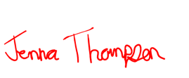
SELLER
Signature: Date: 06/02/2022
Printed Name: Jenna Thompson

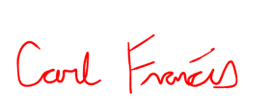
BUYER
Signature: Date: 06/02/2022
Printed Name: Carl Francis

WITNESS (OPTIONAL)
Signature: Date:
Printed Name:

NOTARY ACKNOWLEDGEMENT
State of:
County of:

On this day of , 20 before me, , personally appeared , and , proved to me on the basis of satisfactory evidence to be the person(s) whose name(s) is/are subscribed to the within instrument and acknowledged to me that he/she/they executed the same in his/her/their authorized capacity, and that by his/her/their signature(s) on the instrument, the person(s) or the entity upon behalf of which the person(s) acted, executed the instrument.
To be completed by a Notary Public ONLY

Notary Signature Printed Name
My Commission Expires:
(Seal)

