SAMPLE EQUIPMENT BILL OF SALE

For goods and other consideration and in payment of the sum of $44,500
the undersigned Seller: Kasey Bowman (Seller’s Name)
Of 123 Seller Street, Dallas, TX 75247 (Seller’s Address)
Hereby sells and transfers to Buyer: Phillip Ferrell
Of 321 Buyer Boulevard, Austin, TX 78701 (Buyer’s Address)

Description: Orange in color, originally purchased in Missouri. ________________________
Make: Lull____________________ Model: 1044C-54_______________ Year: 2008_______
Serial No. 5AMPLE-S3R1AL_____________ Hours (if applicable): 3,200________________

The Buyer agrees to pay $44,500 (US Dollars) to the seller, via the following (check one):

☒ Cash | ☐ Cashier’s / Certified Check | ☐ Credit / Debit Card | ☐ Other: _________________

The date of the transfer of funds and the possession of the equipment shall occur on the
3rd day of August , 2025 . Seller acknowledges that they have the full ownership rights and is legally allowed to sell the Equipment. In addition, the Seller is transferring the Equipment with no warranties and strictly in “as-is” condition. At this time, the Equipment is in operating condition.
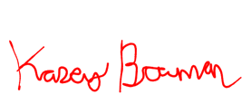
Kasey Bowman 08/03/25
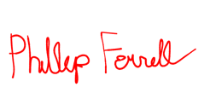
Seller’s Printed Name Seller Signature Date

Phillip Ferrell 08/03/25
Buyer’s Printed Name Buyer Signature Date
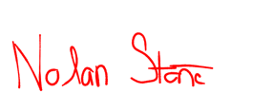

Nolan Stone 08/03/25
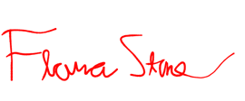
Witness Printed Name Witness Signature Date

Flora Tyrone 08/03/25
Witness Printed Name Witness Signature Date

