RECREATIONAL VEHICLE (RV) BILL OF SALE
In Consideration of the sum of $19,000.00 (US Dollars) paid by
Teddy Neville with a mailing address of 123 Buyer Ln, Phoenix, AZ 85012
(Hereinafter known as the “Buyer”) to Ember Robin with a mailing address of
123 Seller Road, Tucson, AZ 85701 (Hereinafter known as the “Seller”) conveys the following described Recreational Vehicle as:
Make: Winnebago Model: Micro Minnie Year: 2019 Length (ft): 22’5”
Slides (if any): 1 Fuel type (if applicable): N/A Ext. Color: Beige
VIN: 123ABC456DEF789AZ Odometer (if applicable): ~4250
Other: Includes 2 propane tanks w/ brake controller.
Type: ☐ Motorhome | ☒ Trav. Trailer | ☐ 5th Whl | ☐ Pop-up | ☐ Toy Hauler | ☐ Truck Camper
(Hereinafter known as the “Recreational Vehicle”). The Recreational Vehicle is to be sold free and clear of any liens, encumbrances, or mortgages. Seller certifies that to be the legal and true owner of the Recreational Vehicle and is to be sold in “as-is” condition.
IN WITNESS WHEREOF, the buyer and seller agree to the terms of this Bill of Sale on the 8th
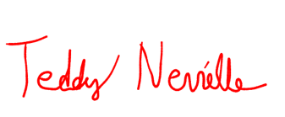
day of March , 2022 .

Teddy Neville 03/08/2022
Buyer’s Printed Name Buyer’s Signature Date
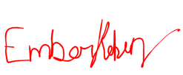
Ember Robin 03/08/2022
Seller’s Printed Name Seller’s Signature Date

Witness signature(s) are optional
Witness Printed Name Witness Signature Date

Witness Printed Name Witness Signature Date

CERTIFICATE OF ACKNOWLEDGMENT

State of
County of
On the day of , 20 , before me, , personally appeared, , , proved to me on the basis of satisfactory evidence to be the person(s) whose name(s) is/are subscribed to the within instrument and acknowledged to me that he/she/they executed the same in his/her/their authorized capacity(ies), and that by his/her/their signature(s) on the instrument the person(s) or the entity upon behalf of which the person(s) acted, executed the instrument.
To be completed by a Notary Public ONLY

WITNESS my hand and official seal,

Notary Signature Print Name

My Commission Expires:

