TRAILER BILL OF SALE
Date of sale: 02 / 12 / 2022__

For goods and other consideration and in payment of the sum of $2750.00
paid by Missy Sutton (Buyer Name) with a mailing address of
21 Roosevelt Road, Bettendorf, Iowa 52722 (the “Buyer”) to Klay West (Seller Name) with a mailing address of
346 Pyramid Road, Iowa City, Iowa 52240 (the “Seller”) conveys the following described trailer as:

Make: H and H Trailer_____________ Model: 7x14 Pull__________________ Year: 2018__
Axles: 1 (single) Type: Utility___________ VIN: 5J22WA5202JLJ2323__________________
Other: Condition is used.______________________________________________________

(Hereinafter known as the “Trailer”). The Trailer is to be sold free and clear of any liens, encumbrances, or mortgages. Seller certifies that to be the legal and true owner of the Trailer and is to be sold in “as-is” condition.

IN WITNESS WHEREOF, the buyer and seller agree to the terms of this Bill of Sale on the 2nd
day of February , 2022 .
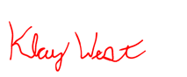
Klay West 02/12/2022
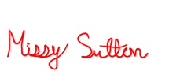
Seller’s Printed Name Seller Signature Date

Missy Sutton 02/12/2022
Buyer’s Printed Name Buyer Signature Date

- - - - - - - - - - - - - - - - - - - - - - - - - - - - - - - - - - - - - - - - - - - - - - - - - - - - - - - - - - - - - - - - - - - - - -
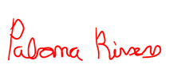
Paloma Rivers (optional) 02/12/2022
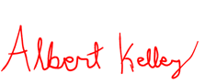
Witness Printed Name Witness Signature Date

Albert Kelley (optional) 02/12/2022
Witness Printed Name Witness Signature Date

ACKNOWLEDGMENT OF NOTARY PUBLIC

State of
County of

On the day of 20 before me, , personally appeared, , , proved to me on the basis of satisfactory evidence to be the person(s) whose name(s) is/are subscribed to the within instrument and acknowledged to me that he/she/they executed the same in his/her/their authorized capacity(ies), and that by his/her/their signature(s) on the instrument the person(s) or the entity upon behalf of which the person(s) acted, executed the instrument.
To be completed by a Notary Public ONLY
WITNESS my hand and official seal,

___________________________________ Notary Public
(Seal)
My commission expires: _______________

