CASH APP DIRECT DEPOSIT AUTHORIZATION

Name: [PAYEE NAME] Address: [PAYEE ADDRESS]

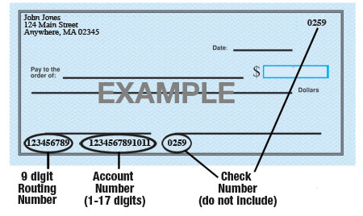

Name of Bank: [NAME OF BANK]
Account #: [ACCOUNT NUMBER]
9-Digit Routing #: [ROUTING NUMBER]

Amount: ☐ $ [DOLLAR AMOUNT] ☐ [PERCENTAGE] % or ☐ Entire Amount
Type of Account: ☐ Checking ☐ Savings

Attach a voided check for each bank account to which funds should be deposited (if necessary).
[PAYOR NAME] is hereby authorized to directly deposit my pay to the account listed above. This authorization will remain in effect until I modify or cancel it in writing.

Payee Signature: ______________________ Date: ____________

