CREDIT REPORT DISPUTE LETTER [SAMPLE]

Date: 02/15/2021
Full Name: Jeremy Massy
Address: 1234 Credit St
City, State, ZIP Code: Montclair, NJ 07042
SSN: 123-45-567 DOB: 04-23-1965

TransUnion Consumer Solutions
P.O. Box 2000
Chester, PA 19016-2000

Dear Sir or Madam,

I am writing to dispute that an account is falsely listed on my credit report with your bureau. The amount owed for the following account is no longer outstanding:

Company Name: Creditor Entity, LLC

Amount: $9,250.00

Reason for Dispute:
☐ - This is not my account
☒ - I have never made a late payment
☐ - This account is more than seven (7) years old
☐ - This account is in bankruptcy
☒ - This account is closed
☒ - I have paid this account in full
☐ - I paid this before it went to collections
☐ - Other: .

This is my official request to have the listed account investigated and removed from my credit report.

I have circled the account I dispute on the attached copy of my credit report. Enclosed may be additional evidence to support my claim.

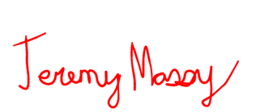
Sincerely,

Signature

