DEBT COLLECTION LETTER [SAMPLE]

From:
Codie Rudd
Creditor Company, LLC
123 Company St
San Diego, CA 12345

Date: September 1st, 2021

To:
Calista Simpson
100 Debtor Rd
San Francisco, CA 54321

URGENT: PLEASE RECTIFY THIS MATTER IMMEDIATELY

Dear Calista Simpson,

Please be advised that you have an outstanding balance at the time of writing. As such, we would appreciate you making this payment as soon as possible.

DUE AMOUNT: $1,500.00
PLEASE REMIT PAYMENT TO: 123 Company St, San Diego, CA 12345

We regret to advise that unless payment is received by October 1st, 2021, this collection will be passed over to our debt collection agency / lawyer. This could seriously affect your credit rating and therefore urge you contact us immediately to make payment or arrange an alternative before this date.

You have the right to dispute this debt by submitting written notice within thirty (30) days of receiving this letter. If this letter is not disputed within the thirty (30) day time-frame allotted, then the collection will be considered accepted by the debtor.

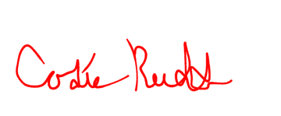
Sincerely,

(Sender Signature)

Codie Rudd
Collections Supervisor

