DEBT FORGIVENESS LETTER [SAMPLE]

From:
Lenny Stewart
Collection Agency Name, Inc
321 Creditor Blvd, Suite 10A
Plano, TX 75023

To:
Kirby Haworth
123 Debtor Drive
Indianapolis, IN 46225

Date: November 15th, 2025

NOTICE: DEBT FORGIVEN IN-FULL

Dear Mr. Stewart,

We are contacting you today regarding your debt in the amount of
Two-Hundred Fifty Dollars ($250.00) for the following:
Phone and internet bill originally issued on September 3rd, 2021.

Due to extenuating circumstances, combined with the amount of the debt you owe, we have taken it upon ourselves to completely relieve you of this debt.

As we have cancelled your debt, please accept any future attempts we make to collect a debt. Thank you for being a loyal customer of ours.

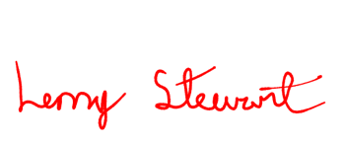
Sincerely,

(Sender Signature)

Lenny Stewart
Supervisor, Credit Collections

