DEBT VALIDATION LETTER [SAMPLE]

Terry Curtis
321 Debtor Drive
Boca Raton, FL 33487

Credit Collector Company, LLC
123 Creditor St, Suite 55
Newark, DE 19714

Date: August 15th, 2022

To Whom it May Concern:

This letter is being sent to you in response to a notice sent to me on
08/11/2022 regarding account #123456789.

Be advised this is not a refusal to pay, but a notice sent pursuant to the Fair Debt Collection Practices Act, 15 USC 1692g stating your claim is disputed and validation is requested.

This is not a request for “verification” or proof of my mailing address, but a request for VALIDATION made pursuant to the above-named Title and Section. I respectfully request your offices provide me with evidence that I have any legal obligation to pay you, including the following documentation:
- Agreement with the creditor that authorizes you to collect on this alleged debt;
- The agreement bearing my signature stating that I have agreed to assume the debt;
- Valid copies of the debt agreement stating the amount of the debt and interest charges;
- Proof that the Statute of Limitations has not expired;
- Complete payment history on this account along with an accounting of all additional charges being assessed;
- Proof that you are licensed to collect in my state; and
- Your license numbers and Registered Agent.
At this time, I will also inform you that if your offices have reported invalidated information to any of the 3 major credit bureaus (Equifax, Experian, or TransUnion) this action may constitute fraud under both Federal and State Laws. Due to this fact, if any negative mark is found on any of my credit reports by your company or the company that you represent, I will not hesitate in bringing legal action against you and your client for the following: Violation of the Fair Credit Reporting Act, Violation of the Fair Debt Collection Practices Act, and Defamation of Character.

If your office fails to reply to this debt validation letter within thirty (30) days from the date of your receipt, all instances related to this account must be immediately deleted and completely removed from my credit file. Moreover, all future attempts to collect on the said debt must be ceased.

Your non-compliance with my request will also be construed as an absolute waiver of all claims to enforce the debt against me and your implied agreement to compensate me for court costs and attorney fees if I am forced to bring this matter before a judge.

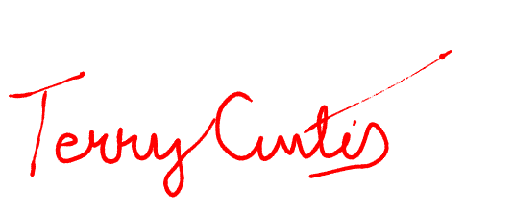
Sincerely,

Terry Curtis

