**FIDELITY INVESTMENTS DEPOSIT AUTHORIZATION**

**Name**: [PAYEE NAME] **Address**: [PAYEE ADDRESS]

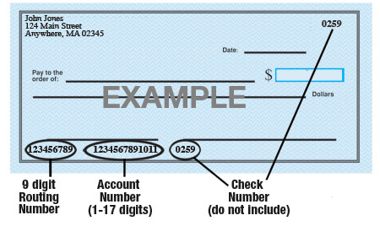

**Name of Bank**: [NAME OF BANK]

**Account #**: [ACCOUNT NUMBER]

**9-Digit Routing #**: [ROUTING NUMBER]

**Amount**:  $ [DOLLAR AMOUNT]  [PERCENTAGE] % or  Entire Amount

**Type of Account**:  Checking  Savings

*Attach a voided check for each bank account to which funds should be deposited (if necessary).*

[PAYOR NAME] is hereby authorized to directly deposit my pay to the account listed above. This authorization will remain in effect until I modify or cancel it in writing.

**Payee Signature:** [______________________](https://esign.com/) Date: ____________