Instrument Prepared By
And Recording Requested By
Space above this line for recorder’s use only

MECHANIC’S LIEN RELEASE SAMPLE

STATE OF CALIFORNIA
COUNTY OF LOS ANGELES

Lien to be Released
Recorded on: 05/25/2022
Recorded in Los Angeles County, State of California .
Book 3 Page: 2
Other information: N/A .

Property (with Lien)
Address: 321 Random St, Los Angeles CA 90017
Property Description: Commence at the NE corner of the East ½ of West ½ of NE ¼ of SW ¼ of Section 22, Township 5 North, Range 12 West. .

Claimant
Name: Brandon Meadows
Address: 123 Claimant Rd, Los Angeles CA 90017

Owner
Name: Richard Hurtado
Address: 456 Owner St, Beverly Hills, CA 90210

KNOW ALL PERSONS that the Claimant, being the owner of the Lien, does hereby release, discharge, and/or acknowledge satisfaction of said Lien. The aforesaid notice and claim of Mechanic’s Lien is released, discharged and/or satisfied for the following reason (check one):

☒ - Payment has been received IN FULL for the lien.
☐ - The Claimant did not enforce the lien within the time required by law, and seeks to
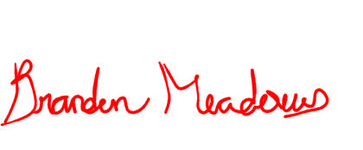
release the lien.
☐ - Other reason: .

Claimant Signature: ___________________________________ Date: 06/19/2022
Claimant Printed Name: Brandon Meadows

NOTARY ACKNOWLEDGMENT

State of _________________
County of _________________
DO NOT WRITE
FOR NOTARY PUBLIC ONLY
The foregoing instrument was acknowledged before me this ________________ (mm/dd/yyyy), by the undersigned, ________________________, who is personally known to me or satisfactorily proven to me to be the person whose name is subscribed to the within instrument.

_________________________________
Notary Public

My Commission Expires: _____________________

