STANDARD PROMISSORY NOTE

UNSECURED

This Unsecured Promissory Note (“Note”) is made as of this 10/25/2022, hereinafter known as the "Start Date", by and between:

Kristi Reed of 1234 Science Drive, Twin Falls ID 83301, (“Borrower”), has received and promises to payback

Craig Morgan of 4321 Astronomy Lane, Winchester KY 40391 (“Lender”) the principal sum of Fifteen-thousand US Dollars ($15,000.00) with interest accruing on the unpaid balance at a rate of 3.5 percent per annum, hereinafter known as the "Borrowed Money", beginning as of the Start Date in the manner as follows:

- PAYMENTS. The full balance of this Note, including all accrued interest and late fees, is due and payable on 10/25/2025, hereinafter known as the "Due Date". The Loan shall be due and payable in one (1) of the following ways (check one):

☐ - LUMP SUM. Borrower shall pay a lump sum to be made in-full, principal and interest included, of Dollars ($ ) by the Due Date.

☒ - INSTALLMENTS. Borrower shall pay principal and interest in the amount of
Four hundred thirty-nine Dollars ($439.00) on: (check one)

☐ - A weekly basis with any remaining balance payable on the Due Date.
☒ - A monthly basis with any remaining balance payable on the Due Date.
☐ - A quarterly basis with any remaining balance payable on the Due Date.

- LATE FEE. There shall be a late payment fee of $25.00 if an installment is not paid on-time (by the due date) along with the default interest due, as described in Section 4.

- CO-SIGNER. (check one)

☒ - CO-SIGNER. This Note shall have a Co-Signer, known as
Phillip Hopkins (Co-Signer Name) hereinafter known as the "Co-Signer” and agrees to the liabilities and obligations on behalf of the Borrower under the terms of this Note. If the Borrower does not make payment, the Co-Signer shall be personally responsible and is guaranteeing the payment of the principal, late fees, and all accrued interest under the terms of this Note.

☐ - NO CO-SIGNER. This Note shall not have a Co-Signer.

- INTEREST DUE IN THE EVENT OF DEFAULT. In the event the Borrower fails to pay the note in-full on the Due Date, unpaid principal shall accrue interest at the maximum rate allowed by law, until the Borrower is no longer in default.

- ALLOCATION OF PAYMENTS. Payments shall be first credited any late fees due, then to interest due and any remainder will be credited to principal.

- PREPAYMENT. Borrower may pre-pay this Note without penalty.

- ACCELERATION. If the Borrower is in default under this Note or is in default under another provision of this Note, and such default is not cured within the minimum allotted time by law after written notice of such default, then Lender may, at its option, declare all outstanding sums owed on this Note to be immediately due and payable.

- ATTORNEYS’ FEES AND COSTS. Borrower shall pay all costs incurred by Lender in collecting sums due under this Note after a default, including reasonable attorneys’ fees. If Lender or Borrower sues to enforce this Note or obtain a declaration of its rights hereunder, the prevailing party in any such proceeding shall be entitled to recover its reasonable attorneys’ fees and costs incurred in the proceeding (including those incurred in any bankruptcy proceeding or appeal) from the non-prevailing party.

- WAIVER OF PRESENTMENTS. Borrower waives presentment for payment, notice of dishonor, protest and notice of protest.

- NON-WAIVER. No failure or delay by Lender in exercising Lender’s rights under this Note shall be considered a waiver of such rights.

- SEVERABILITY. In the event that any provision herein is determined to be void or unenforceable for any reason, such determination shall not affect the validity or enforceability of any other provision, all of which shall remain in full force and effect.

- INTEGRATION. There are no verbal or other agreements which modify or affect the terms of this Note. This Note may not be modified or amended except by written agreement signed by Borrower and Lender.

- CONFLICTING TERMS. The terms of this Note shall control over any conflicting terms in any referenced agreement or document.

- NOTICE. Any notices required or permitted to be given hereunder shall be given in writing and shall be delivered (a) in person, (b) by certified mail, postage prepaid, return receipt requested, (c) by facsimile, or (d) by a commercial overnight courier that guarantees next day delivery and provides a receipt, and such notices shall be made to the parties at the addresses listed below.

- EXECUTION. The Borrower executes this Note as a principal and not as a surety. If there is a Co-Signer, the Borrower and Co-Signer shall be jointly and severally liable under this Note.

- GOVERNING LAW. This note shall be governed under the laws in the State of
Kentucky.

- ADDITIONAL TERMS & CONDITIONS.

None.

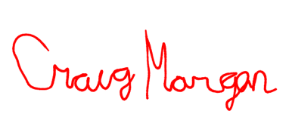
- SIGNATURE AREA

Lender Signature: Date: 10/25/2022

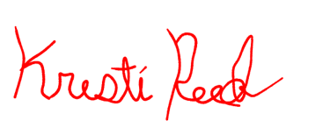
Printed Name: Craig Morgan

Borrower Signature: Date: 10/25/2022

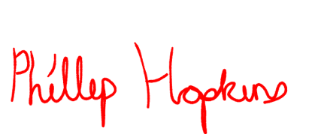
Printed Name: Kristi Reed

Co-Signer Signature: Date: 10/25/2022

Printed Name: Phillip Hopkins

- - - - - - - - - - - - - - - - - - - - - - - - - - - - - - - - - - - - - - - - - - - - - - - - - - - - - - - - - - - - - - - - - - -

Witness Signature: Date:

Printed Name:

Witness Signature: Date:

Printed Name:

